Food Webs – How did the elimination and return of wolves
affect other populations in Yellowstone?

Wolves in Yellowstone National Park
In the early twentieth century, humans eliminated wolves from Yellowstone. In the late twentieth century, humans brought wolves back to Yellowstone. You will learn how these changes in the wolf population affected the populations of other animals and plants in Yellowstone.

To begin, watch part of the “Ecosystems Video” (https://www.learner.org/series/the-habitable-planet-a-systems-approach-to-environmental-science/ecosystems/ecosystems-video/); begin at 13 minutes and 40 seconds (right when the video switches from a tropical ecosystem to Yellowstone) and end at 22 minutes (right after the researcher shows that tall willows escape browsing). An ecosystem includes the animals, plants and other organisms in an area and their physical environment.

These graphs summarize recent trends in the numbers of wolves and elk in the Northern Range in Yellowstone National Park.  1. Why did the number of elk decrease after 1995?  2a. What happened to the number of elk in Yellowstone after wolves were eliminated from Yellowstone in the early twentieth century? | 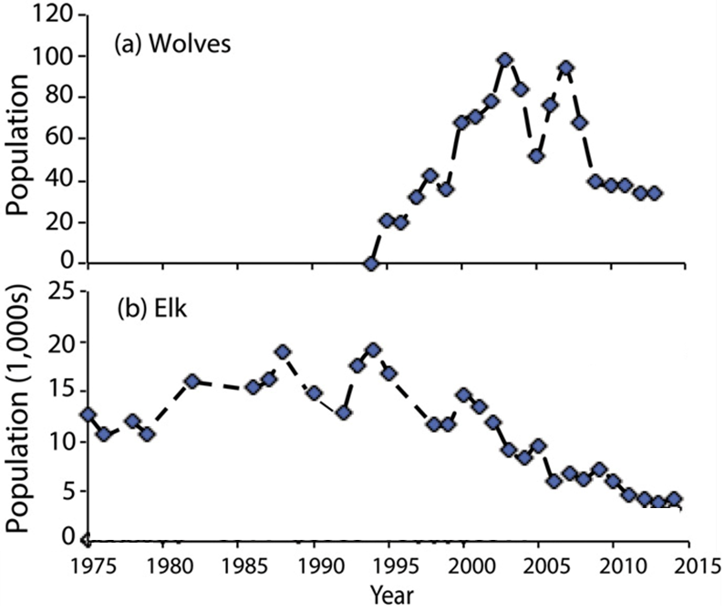

2b. After wolves were eliminated from Yellowstone, willow growth decreased. What is a likely explanation for this trend in willow growth?

3a. Beavers use tall willows for food and building dams. Predict the change in the number of beavers when wolves were eliminated from Yellowstone. decreased ___ increased ___

3b. Explain your reasoning.

We will return to these questions after you have learned more during this activity.
Food Chains and Food Webs

A food chain summarizes a sequence of trophic relationships. Trophic means eating or nutrition. As shown in this figure, producers (plants) are eaten by primary consumers (herbivores), and primary consumers are eaten by secondary consumers (predators). | 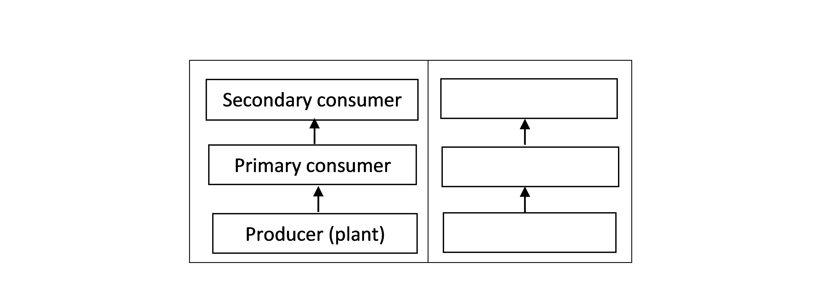
4a. To show a specific food chain, write grass, rabbit and mountain lion in the appropriate blank boxes.
4b. Primary consumer and herbivore are different names for an animal that eats ___________.
4c. Each arrow in a food chain points from an organism that ______________________ to an organism that _____________________ .

There is another type of food chain that doesn’t begin with living plants. Think about a 100-year-old forest where the leaves have dropped from the trees each fall, dead branches have fallen, and animals have died each year. But, you won’t see 100 years of dead stuff piled up on the ground in the forest.

5. What do you think has happened to all the dead stuff?

Decomposers get their nutrition from dead organic matter. Two major types of decomposers are bacteria and fungi (e.g. mushrooms). These bacteria and fungi secrete digestive enzymes into dead organic matter and absorb digested molecules. Thus, all the dead stuff is eventually digested.

The first flowchart on the right shows a food chain that begins with dead organic matter. The second flowchart shows an example of this type of food chain in Yellowstone.  6. If you visited Yellowstone, you might not notice this food chain. Why not? | 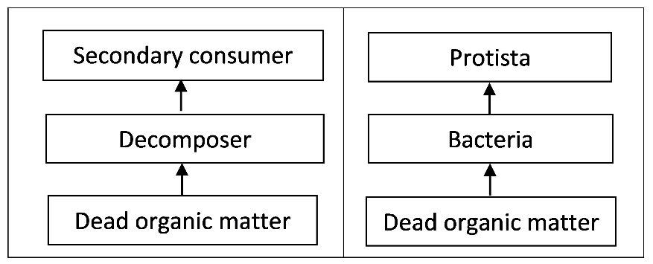

7. Match each item in the left list with the best match or matches from the right list.

Producer ___ a. an animal that eats plants
Primary consumer ___ ___ b. an organism that consumes dead organic matter
Secondary consumer ___ ___ c. an organism that eats primary consumers
Decomposer ___ d. an organism that eats producers
e. an organism that makes its own organic molecules from
small inorganic molecules (e.g. uses photosynthesis to
make sugars from CO₂ and H₂O)
f. includes some predators and Protista

In real biological communities, the trophic relationships are much more complex than a simple food chain. These more complex trophic relationships are summarized in a food web.

This figure shows a small part of a food web. Notice that the food web contains multiple food chains.  8. Use asterisks (*) to mark the organisms in one food chain in this food web.  Most of the organisms in this food web can be classified in one of these trophic levels:  - producers  - primary consumers  - secondary consumers. | 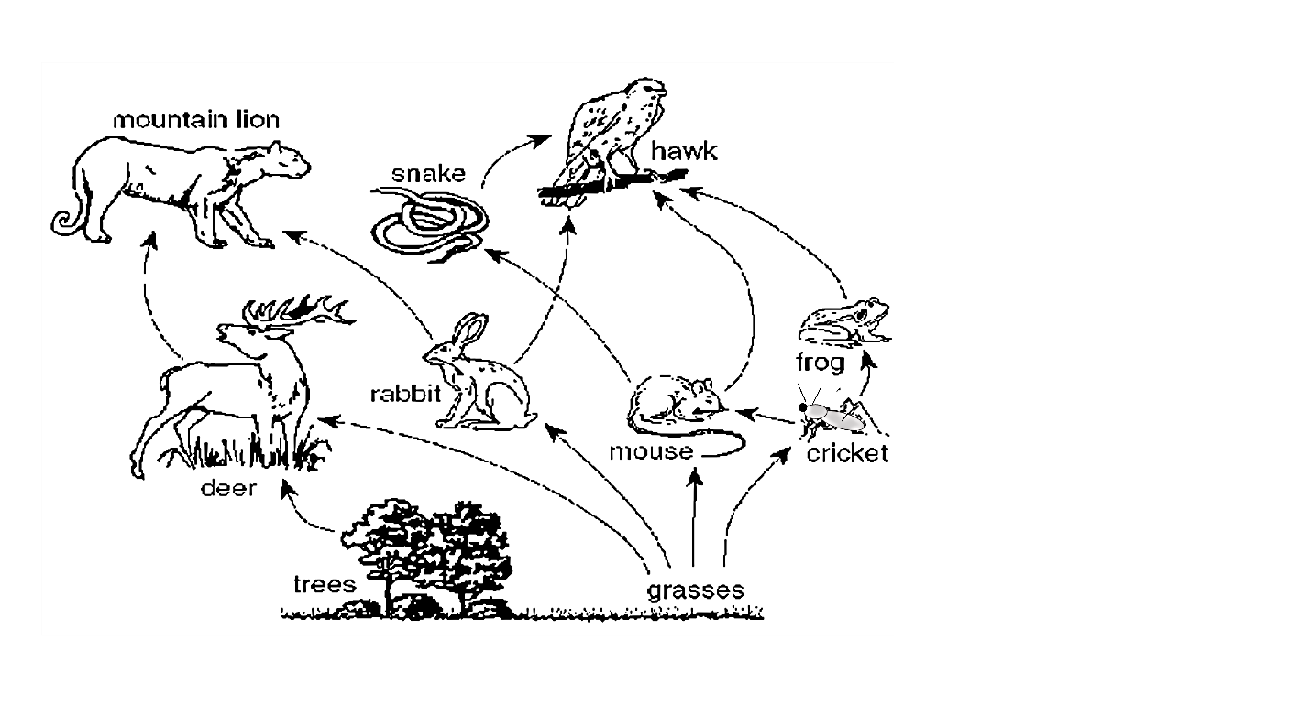
However, not all organisms fit in a single trophic level. You may have heard of omnivores which eat both plants and animals. A more general category is a trophic omnivore, which is any animal that eats organisms from more than one trophic level.

9. In the above figure, use one of the following symbols to label each type of organism.
P = Producer (There are 2 of them.)
PC = Primary Consumer (3)
SC = Secondary Consumer (2)
TO = Trophic Omnivore (3; any animal that eats trophic omnivores is a trophic omnivore.)

Trophic Relationships in Yellowstone
In the procedure below, complete each step and check the box before beginning the next step.

- Pages 5-7 show some of the organisms that live in Yellowstone National Park. Find the producers and write their names in the appropriate blanks in the chart below.
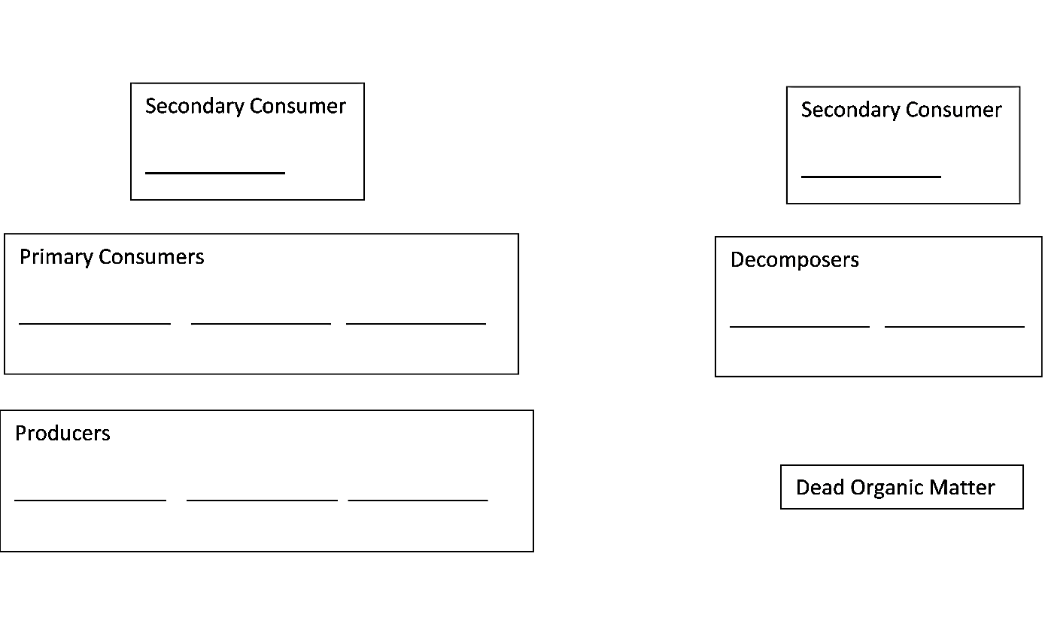

- Find the primary consumers (which eat only producers) and the decomposers (which consume only dead organic matter). Write their names on the blanks in the rectangles for primary consumers and decomposers. Draw an arrow to show each trophic relationship described on the cards.
- Fill in the blanks for the secondary consumers and write the names of the trophic omnivores in appropriate places outside the rectangles. (Any animal that eats trophic omnivores is also a trophic omnivore.) Draw an arrow to show each trophic relationship described on the cards.

Your Yellowstone food web may look complex, but a complete Yellowstone food web would be much more complex. Here are some causes of this additional complexity.
- Many more types of organisms live in Yellowstone, including more than 1000 different kinds of plants and more than 1000 different kinds of insects.
- The trophic relationships are more complex than is shown in your food web. For example, when an elk is killed by a pack of wolves, the wolves eat much of the meat, but some of the rest is eaten by other animals such as bears, coyotes, eagles and ravens. After animals have finished eating, the remaining dead organic matter is consumed by decomposers.
- Some of the trophic relationships in your food web are much more important than others. For example, Yellowstone wolves eat many elk and few beavers.

10a. To add a little of this complexity to your food web, make the arrow from elk to wolves fatter to represent the importance of this trophic relationship.

10b. Draw arrows from the producers and primary consumers to dead organic matter. These arrows will represent the general point that, every year, many plants and animals become dead organic matter.

11. Your teacher may suggest improvements for your food web. After you have made any suggested improvements, take a picture of your food web to submit to your teacher.

Even though your food web is incomplete, it can help you to predict and understand important
ecological phenomena.  A trophic cascade occurs when a change in the size of a predator population has indirect effects on the size of another population in the ecosystem.  12. As shown in this figure, wolves reduce the number of elk, and elk reduce the number and size of willow shrubs. Show the indirect effect of wolves on the willow population with a curved arrow and (+) or (-) to indicate whether increases in the number of wolves result in increased or decreased willow growth. | 

13. After wolves were eliminated from Yellowstone, the number of beaver colonies decreased. What is a likely explanation? (Hint: Remember that beavers use tall willows for building dams and for food.)

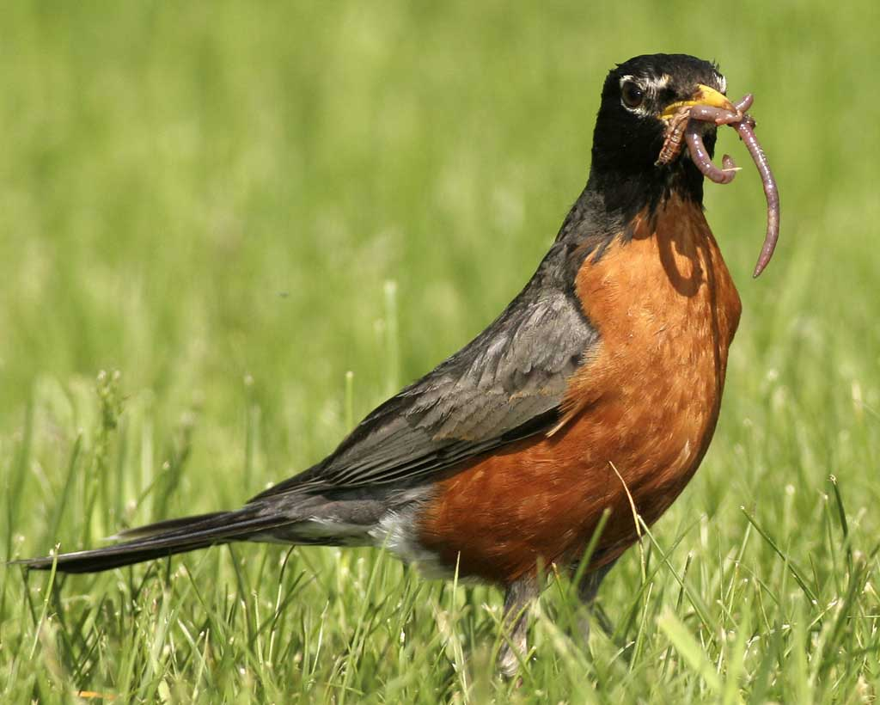  23-28 cm  American Robins  Eat: Earthworms, beetles,  other flowering plants  Eaten by: Snakes and  birds of prey (not  included in this food web) | 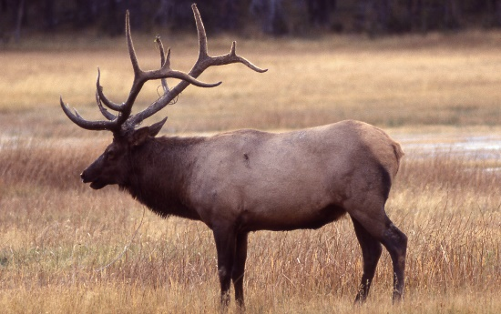  2.1-2.4 m  Elk  Eat: Grasses, willows,  other flowering  plants  Eaten by: Gray wolves,  grizzly bears, coyotes | 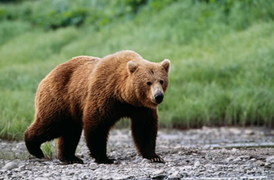  1.8-3.3 m  Grizzly Bears  Eat: Other flowering  plants (including  berries), elk
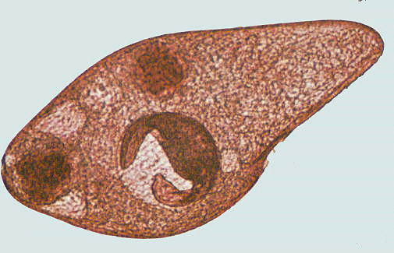  <1 mm  Protista  Eat: Bacteria  Eaten by: Nematodes | 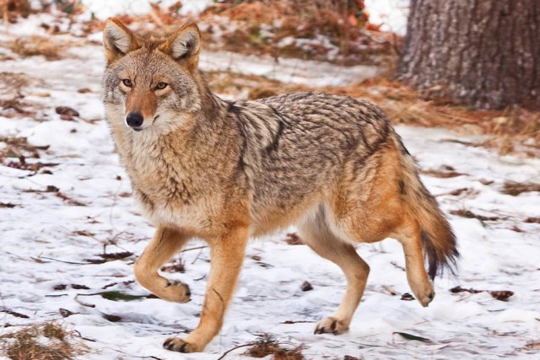  1-1.4 m  Coyotes  Eat: deer mice, elk  Eaten by: Gray wolves | 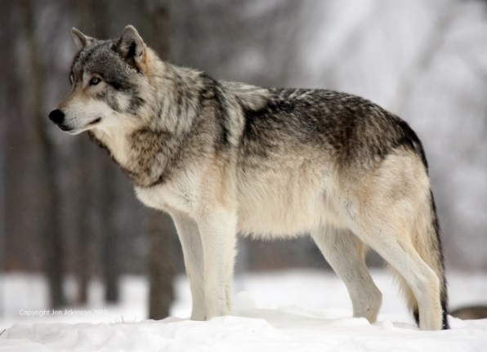  1.4-2 m  Gray Wolves  Eat: Elk, coyotes, beavers

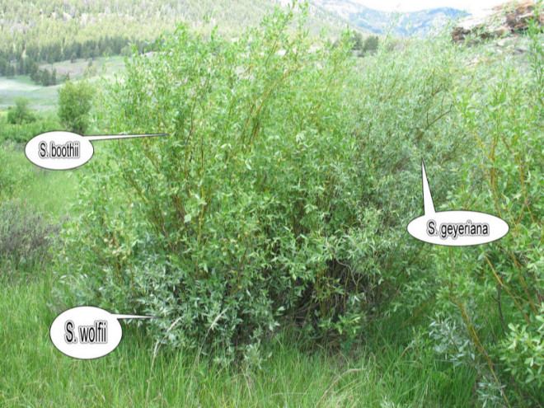  <80-400 cm  Willows  Eaten by: Elk, beavers | 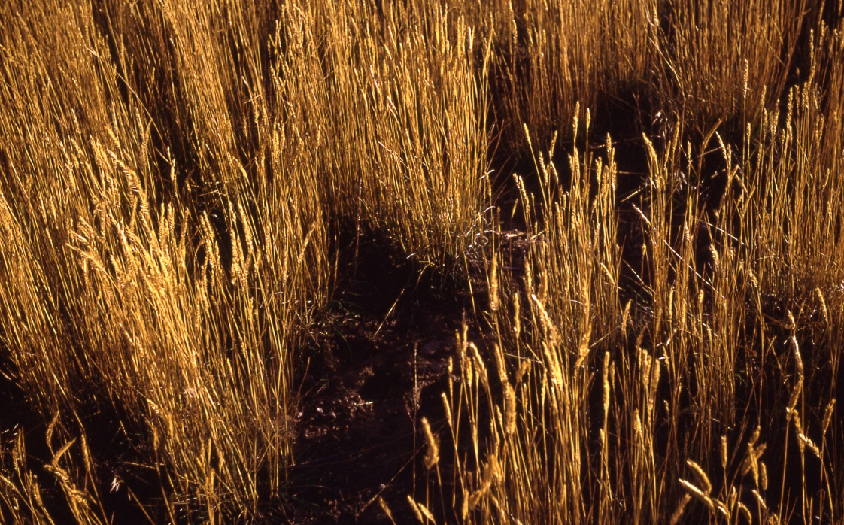  Grasses (including seeds)  Eaten by: Elk, deer mice | 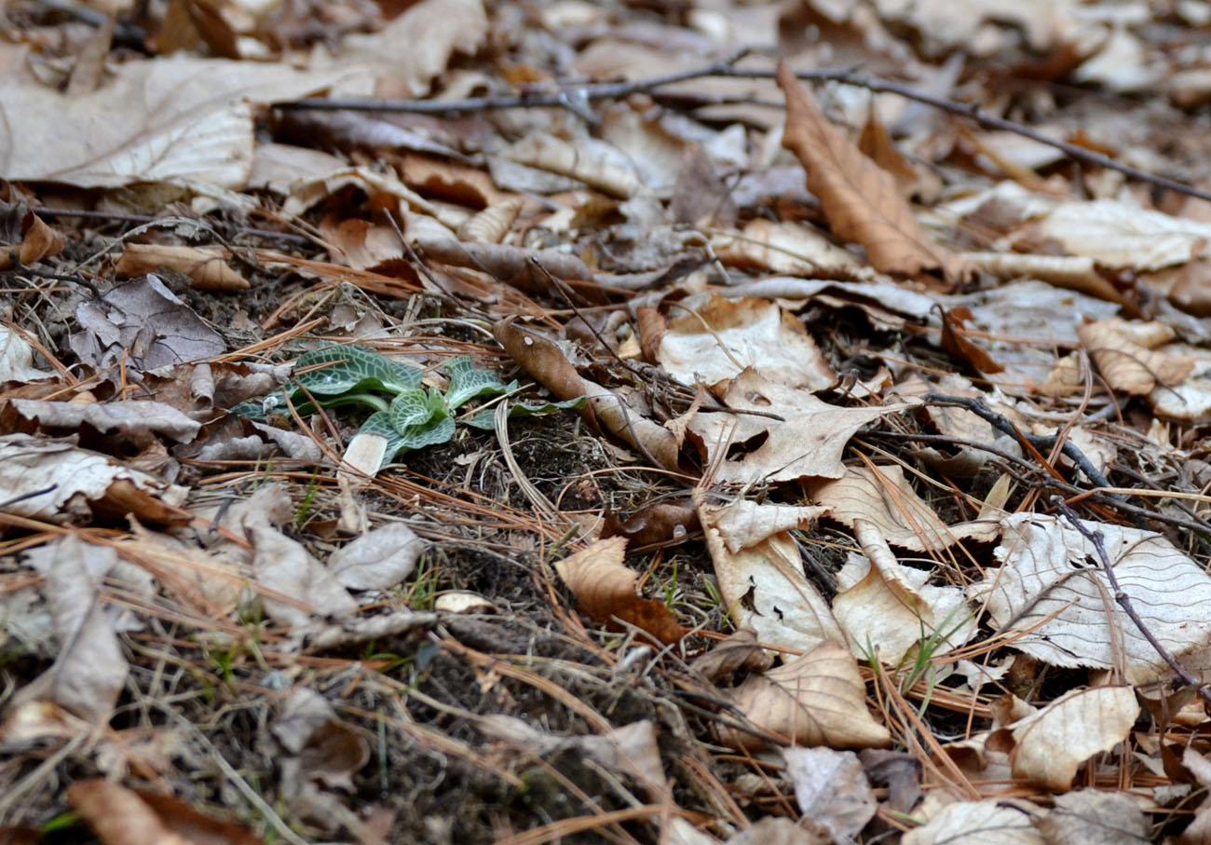  Dead Organic Matter  Consumed by: Bacteria,  fungi, earthworms
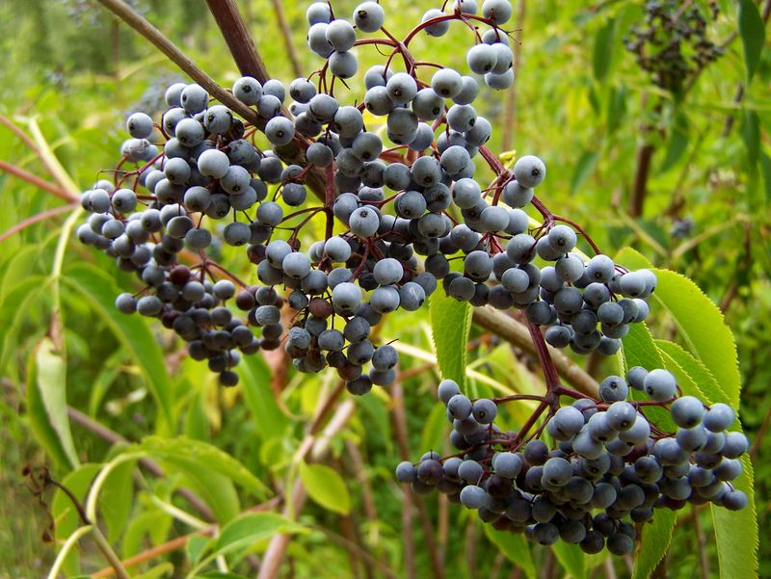  Other flowering plants  (including berries)  Eaten by: American  robins, deer mice,  elk, grizzly bears | 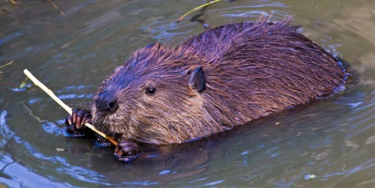58-99 cm (length, excluding tail)  Beavers  Eat: Willows  Eaten by: Gray wolves | 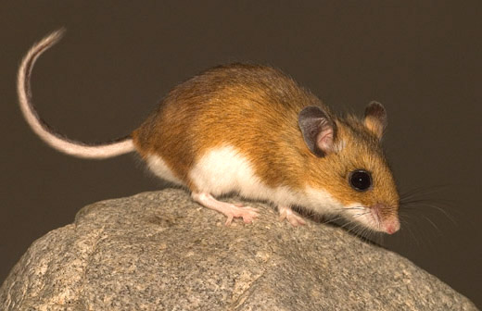  8-10 cm (length, excluding tail)  Deer Mice  Eat: Grasses; other  flowering plants  Eaten by: Coyotes

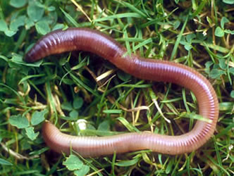  7-35 cm  Earthworms  Eat: Dead organic matter,  fungi, bacteria  Eaten by: American robins | 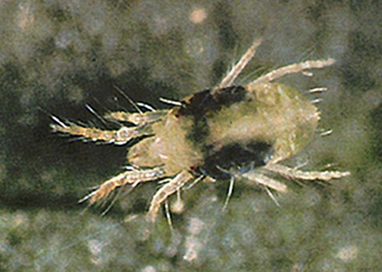  0.5-1 mm  Mites  Eat: Nematodes, fungi  Eaten by: Beetles | 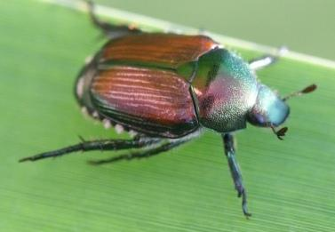  5-20 mm  Beetles  Eat: Mites  Eaten by: American  robins
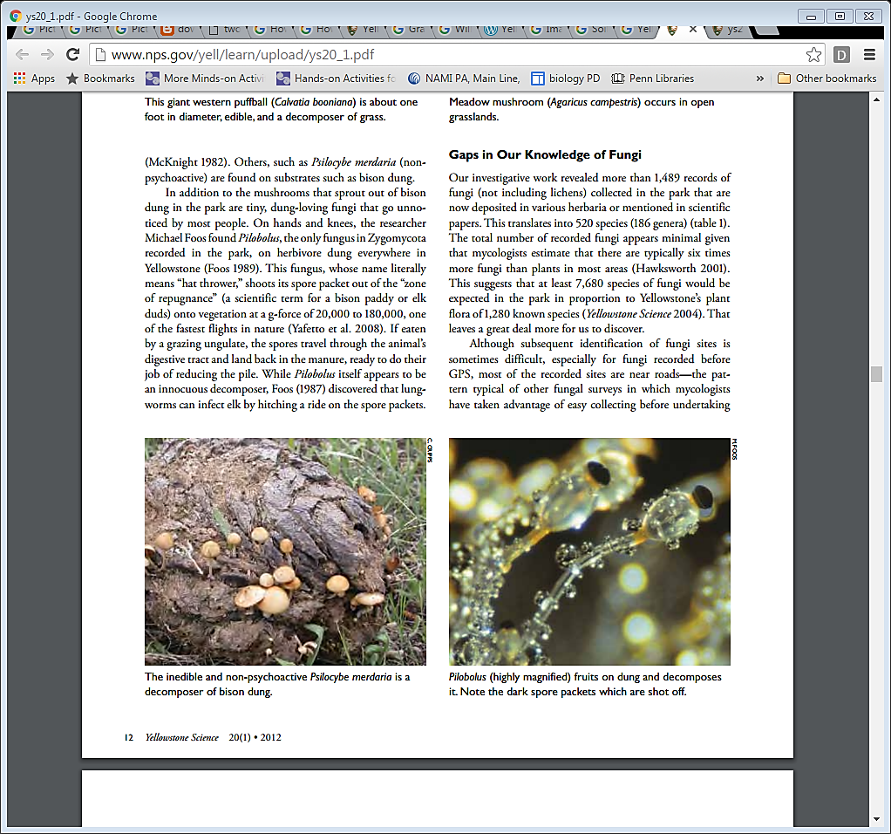  Fungi  Consume: Dead organic  matter  Eaten by: Earthworms,  mites, nematodes, | 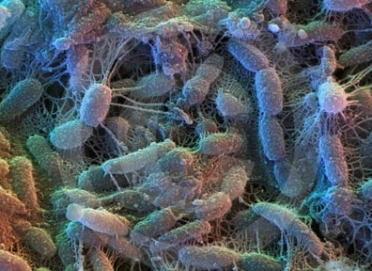  2-6 µm  Bacteria  Consume: Dead organic  matter  Eaten by: Protista,  nematodes,  earthworms | 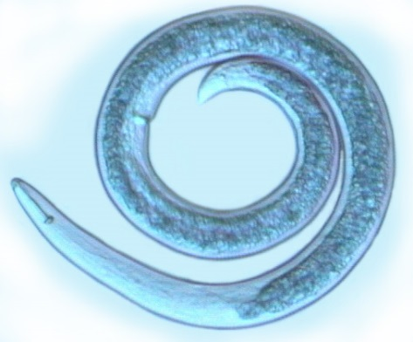  0.1-2.5 mm  Nematodes  Eat: Protista, fungi,  bacteria  Eaten by: Mites

By Drs. Ingrid Waldron and Lori Spindler, Dept Biology, University of Pennsylvania. © 2024. This Student Handout, an alternative version for students who are learning in the classroom or at home with a printer, and the Teacher Preparation Notes with instructional suggestions and background information are available at https://serendipstudio.org/exchange/bioactivities/foodwebRR.

